THE UNIVERSITY OF AZAD JAMMU & KASHMIR MUZAFFARABAD



Name: Zoya Mazhar
Roll no: 2024-SE-26
Course: Software Consyruction
Submitted to: Mam Asma

Department of Software Engineering

Q1: Online Ticket Reservation System
Objective
To develop a use case diagram for an online ticket reservation system and identify its actors and use cases.
Introduction
An online ticket reservation system allows customers to search for available tickets, select tickets, make reservations, and pay online. It also allows the administrator to manage tickets and reservations.
Actors
Customer: Searches for tickets, selects tickets, makes reservations, pays online, and receives
Administrator: Manages ticket information and reservations.
Payment Gateway: Processes online payments and returns the payment status.
Use Cases
Register / Log In
Search Tickets
View Availability
Select Ticket
Book Ticket
Make Payment
Receive Confirmation
Cancel Reservation
Manage Tickets
Manage Reservations
Use Case Diagram
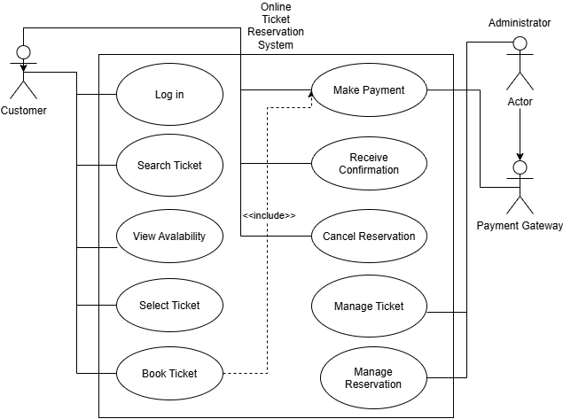
Conclusion
The use case diagram shows the main functions of an online ticket reservation system and how the customer, administrator, and payment gateway interact with it.
Q2: Credit Card Processing System
Objective
To identify the actors and use cases of a credit card processing system and develop its use case diagram.
Introduction
A credit card processing system is used when a customer purchases an item from a shop and pays using a credit card. The vendor prepares the bill, processes the card transaction, and provides a receipt. The customer signs the receipt and returns it to the vendor.
Actors
Customer: Selects an item, provides the credit card, signs the receipt, and returns the signed receipt.
Vendor: Prepares the bill, operates the card reader, enters the transaction amount, and provides the receipt.
Bank / Credit Card Authorization System: Verifies the credit card, authorizes the transaction, and supports the updating of the credit balance after an approved transaction.
Use Cases
Select Item
Generate Bill
Swipe Credit Card
Enter Transaction Amount
Verify Credit Card
Process Transaction
Update Credit Card Balance
Generate Receipt
Sign Receipt
Return Signed Receipt
Use Case Diagram
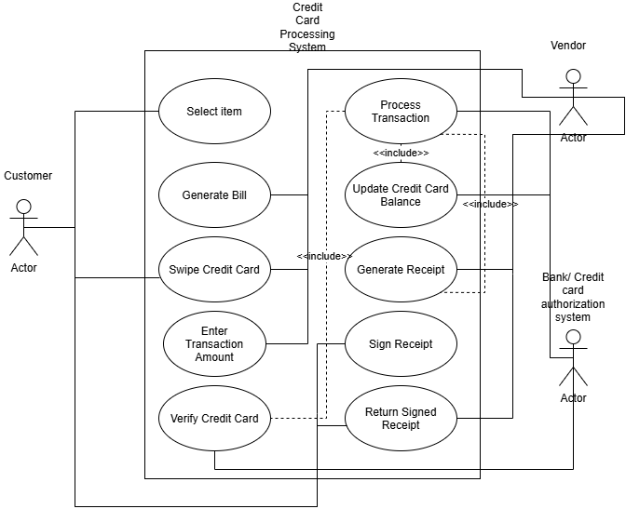
Conclusion
The use case diagram represents the main activities involved in credit card processing. It shows how the customer, vendor, and bank or credit card authorization system participate in the transaction.

